

Parent / Carer Information
2024 – 2025

WELCOME TO HORTON PARK PRIMARY SCHOOL
Everything you need to know about our school is in this booklet

We have done our best to make it quick and easy to read, however we have, by law, to include many items. If you have any questions, suggestions or want to know more, please get in touch with us.
On behalf of the governors, staff and children of Horton Park Primary School, we would like to warmly welcome you to our school.
We are a popular, two-form entry primary school, located at the heart of the Canterbury estate in Bradford, West Yorkshire. We are also part of Exceed Academies Trust and work collaboratively with other highly successful schools to ensure the best opportunities are provided to our children and the community.

We recommend a visit to look round our wonderful school.

ABOUT OUR SCHOOL:

Chair of Governors: Miss Dajinder Bhambra
Chief Executive Officer: Mr Duncan Jacques
Headteacher: Ms Saima Bahadur
Deputy Headteacher: Mrs Laura Naylor
Assistant Headteachers: Mrs Shahmyla Gulshan
Mrs Catherine MacGilchrist
Miss Lucy Azzopardi
Associate Leader: Mr Hamza Farooq
Early Years Leader: Miss Lucy Azzopardi
Parental Involvement Worker: Mrs Sabrina Arshad

School Address: Horton Park Primary School
Dawnay Road
BRADFORD
BD5 9LQ
Telephone: 01274 574544

E-Mail: office@hortonparkacademy.co.uk

Website: hortonparkprimary.co.uk

Twitter @HortonParkSch

SCHOOL HOURS: 8.40am – 3.10pm
Morning Session - Doors open at 8:30am and school starts at 8.40am
8.40 am – 11:15 pm, Lunch until -12.25 pm (Reception and Key Stage 1)
8.40 am - 12.15 pm-1.10pm (Key Stage 2)
Afternoon Session - 12.25 pm-12:45 pm - 3.10 pm (Reception and Key Stage 1) 12.40 pm-1.10 pm - 3.10 pm (Key Stage 2)

There are no arrangements to supervise children before 8:30am or after 3.10pm, exceptions are for breakfast and before and after school clubs, but children must have written permission from their parent or legal carer to attend each of these. Breakfast Club takes place from 8am – 8.30am.

THE SCHOOL AND GROUNDS ARE A COMPLETELY SMOKE FREE SITE

The information in this booklet was correct at the time of printing (June 2024).
However, there may be unexpected changes during the school year.
Translation of this booklet into community languages is available, please ask in the office.

Our School Vision

To be an outstanding CENTRE FOR EDUCATION at the

HEART of a THRIVING COMMUNITY

Our School Mission

This is the school where EVERYONE LEARNS TO SUCCEED

Our Shared Values

At Our School We:

- Make sure that all in our school community are continually learning, valued and respected.

- Enable individuals to broaden their horizons and explore their opportunities so they can make positive life choices.

- Are forward looking and ambitious in responsibly using our resources and facilities to benefit our whole community, today and in the future.

Safeguarding our Children is a Key Priority

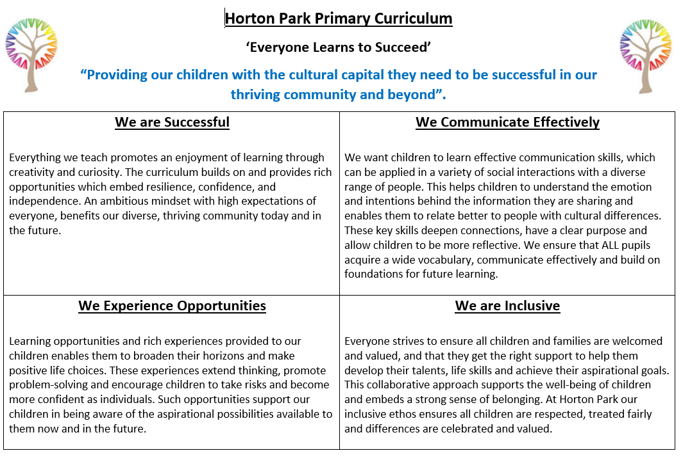

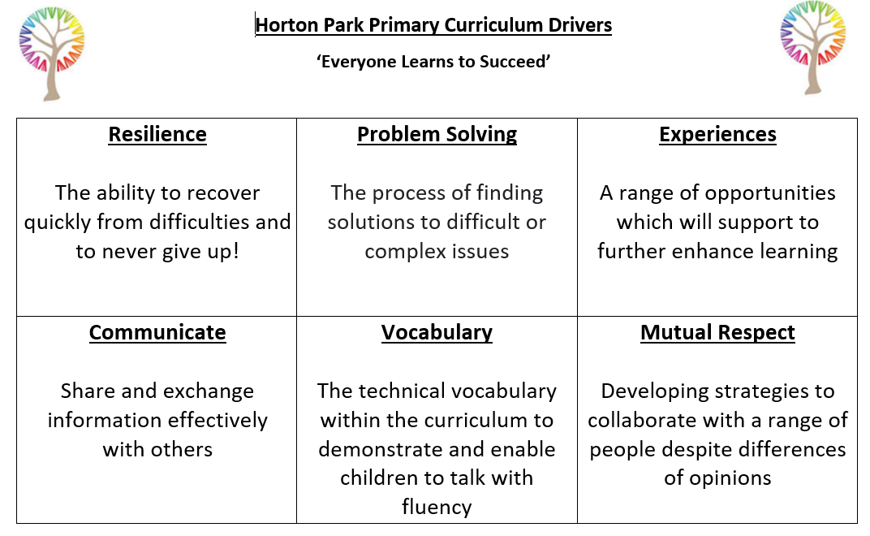

PRACTICAL MATTERS: WHAT YOU NEED TO KNOW

WHAT DO I DO IF I HAVE TO DRIVE MY CHILD TO SCHOOL?
We are part of the School Streets initiative which means that every day between 8:25 and 8:50 and 2:50 to 3:20 access outside school on Dawnay Road will be closed and no vehicle access is allowed. The car park is not for parent or carers use, unless disability access is required.
The school streets initiative is to keep our parents and children are safe and we encourage our pupils to walk or ride their bike/scooter to school, if possible.

CHILDREN WITH ALLERGIC REACTIONS:

If your child has any allergic reactions please tell school before they come into school when we complete the written admission form. This is very important.

WHAT IF MY CHILD HAS A MEDICAL CONDITION?

You must tell staff at your first meeting with us what your child’s needs are:
All children with any medical conditions, short term or long term, must have a medical care plan. This will be written with you and shared with all relevant staff.

Medication: Is stored and administered by office staff / First Aiders.
All medication must be authorised for use by a parent/carer with responsibility.

Asthma: Inhalers are stored in the classroom in a clearly labelled box.
Other medications will only be given if it is prescribed to that child and to be taken four times a day. When the inhaler expires, you will be notified, it is your responsibility to provide a new one immediately.

WHAT WILL MY CHILD EAT AT SCHOOL?

Healthy Snacks: Snack (in Reception) or toast is available at a cost of £5 per half term. This is payable via ParentPay before we break up for half term. Children may bring fruit from home.
Fruit: The government provides free fruit daily for Reception, Year 1 and 2.

Aspens staff prepare our meals in the school kitchen.
Healthy options such as sandwiches and jacket potatoes are always available.
Please talk to the school for any particular dietary needs. We will liaise with the catering team.
All meat is Halal and non-meat meals are available every day.
Please tell us about your child's dietary needs.

School lunches cost £2.10 per day, many of our families can claim free school meals. An application form will be completed during your admissions meeting. Payment for school meals is via ParentPay and you will be given a letter with your activation details. You must follow the instructions on the letter and register on ParentPay. If you have any issues with ParentPay, please contact the Office Manager who will support you.

Free lunch for Reception, Year 1 and Year 2: The government provides funding to school for free daily lunch for children who are in Reception, Year 1 or Year 2.

If you receive any benefits then your child may be entitled to receive free milk, please ask the office staff for more information.

Children can also bring packed lunches, which should be a healthy, balanced meal, or go home for dinner. If your child does go home for dinner they should not come back until the end of their lunch break. We do not have supervision for children who go home.

WHAT WILL MY CHILD DRINK AT SCHOOL?
Water: Each child has a water bottle so that a drink is available throughout the day.
Water is available to all children eating lunch at school, including those having packed lunches. They can bring their own water bottle from home in their packed lunch, but this can only be used at lunchtime.

Milk: Milk is provided from School Milk Online. You will need to register with them after your child starts school. Leaflets with instructions for how to sign up to School Milk Online are available at the office. ALL Reception class children get free milk for the whole year.

Please note: The toast, milk and lunch options for your child can be chosen on a half termly basis and will need to be paid for via ParentPay.

WHAT IF WE ARE LATE TO SCHOOL?
Punctuality is important. Lateness is an unauthorised absence. This is taken very seriously.
Please make sure children are in school on time, so that their own and other children's work is not disturbed. If your child arrives after 8.40 (when the classroom door closes and registration is over), you must report to the office and you will need to sign your child in using Inventry.
Your child will not be included in any attendance rewards if they are late.
Arriving more than 30 minutes after 8:40am, without a good reason, is counted as an unauthorised absence (truancy).

ALL children, especially those under five years old, should be collected by an adult.
If someone different is collecting your child, please tell us as we have to ensure children's safety.
A child cannot go with someone different unless you have given us their name beforehand. You must share these details during your admissions meeting and update if needed. Children should also be collected on time (at 3.10pm) as they may get upset if they have to wait. All contact numbers will be used and an adult will stay with them if you are late to collect.
No child will be sent home with an adult who is not on our contact list or a child under 11 years old.

Please tell us as soon as you change your telephone number, address or there are any family changes - if there is a medical emergency, we may need to contact you very quickly.

Pupils are supervised very closely – if a child was to go missing from school, then all contact numbers will be phoned and the police informed. This would then become a police matter.

WHAT IF MY CHILD CAN'T COME TO SCHOOL ONE DAY?

All children learn best if they come to school every day and we give rewards for good attendance.
If your child is going to be away for an appointment or any other reason, please inform the office and tell us why they are away, otherwise your child's absence will be "unauthorised" - see our Attendance Policy below.

Return to School Forms: If your child has had time off school, the class teacher will complete a form with them when they return to discuss reasons for their absence.

Holidays: THERE IS NO AUTHORISED HOLIDAY LEAVE.
You must put children’s education first and not prioritise any holiday or longer visit, in term time. This must be discussed in person with a member of the Senior Leadership Team or the CIW / Attendance Officer and relevant forms to be completed.
It will not be agreed by school, there is a form to complete and your child may lose their place at our school. A penalty notice will be issued by the Local Authority. Children who have been on long visits find it difficult to catch up with the other children.

WHAT IS THE SCHOOL’S ATTENDANCE POLICY?

1. Attendance at school is the law.
2. We have to be sure that parents or carers know about how our school carries out this law.
3. We help the children to come to school every day and we work with parents or carers on this.
4. We make the children’s time in school interesting and worthwhile.

School has:
- Clear systems for finding out how children and families are doing and how we can help
2. Targets for children, classes, and the school to improve attendance
3. Effective links with educational services - to raise attendance levels

Principles: Children should come to school every day. They should only be absent if it is ‘unavoidable’. Allowing a child to be absent without a good reason is against the law.
Parents or carers can be fined up to £2500 or even imprisoned.

Every half day absence has to be ‘unauthorised’ or ‘authorised’ by the school, not by the parent or carer. Authorised absences are serious illnesses or something completely unavoidable

Unauthorised absences: Unreasonable reasons, not agreed with by school, or too late for the register, dentist appointments, doctors’ appointments etc.

Under the Education Act, school may need to take further steps to improve poor attendance. This could include issuing a warning which could lead to a £60 fine per parent, per child. In more severe cases the matter may be referred to the Magistrates Court where you could be fined up to £2,500 and/or 3 months in custody.

WHAT IF MY CHILD IS ILL?
If a child is unfit for school, the parents or carers should contact school on the first day, in person or by phone.
Mrs Kausar, our Attendance Officer, will contact you if you do not contact us first.

Emergency Appointments: Leave may be granted in an emergency or for medical appointments providing a parent or carer comes into school to let us know and to collect the child.
Please bring the appointment card or practice telephone number with you.

Targets: We let you know the absence figures for the school and the child for the year.
We send home your child’s printed attendance each half term and it is in the child’s progress report in July. Our school’s attendance is above the national average and we work hard to keep it there.

In 2023-2024 our school attendance was: 94%. We need your help to achieve even better!

Rewards: There are individual rewards for attendance each half term, weekly class rewards and individual rewards for 100% attendance at the end of each half term, term and year.
We especially welcome suggestions by parents, carers and children to improve attendance.

WHAT ARE THE RULES OR POLICY FOR GETTING A PLACE AT THIS SCHOOL?
Reception Admissions at Four/Five Years Old:
Children will be admitted to Reception Class in the September of the school year in which they are five.
The school has a planned admission limit, agreed with the L.A, of 60.
The Council allocate places according to their policy. They decide by looking first at:
1. Whether there are brothers or sisters already at the school and who will still be there when the new child comes in;
2. Those that live in the school's "catchment area" for that year of intake.
This means that the Council officer measures who lives nearest to our school.

Primary School Admissions in Years 1, 2, 3, 4, 5 and 6:
The school has a planned admission limit, agreed with the Council, of 60 for all year groups.
A year group is full when it reaches this number.

More children could be allowed into school by the Head or Governors, and allowed by the Council, if appropriate in relation to the school's budget (finances).

If a parent or carer asks for a place where the year group is full, or where all the classes are full, then their child's name will be put on a waiting list with the council. If another child leaves and a place becomes free in the middle of a term then that place will be given to a child by the council, at the beginning of the following term using the following reasons in order:
i) The new child has a brother or sister in school;
ii) The new child lives within the "catchment area" for that year group;
iii) How far the new child's home is from our school.

The Headteacher or senior leader will speak to all new parent or carers about how it can upset a child's progress to move schools.
The new parent or carers will always be asked to talk with the old school's Headteacher and we will contact the previous school.

THERE WILL BE A MEETING AT HOME FOR ALL FAMILIES WANTING A PLACE.

WHAT IF MY CHILD HAS A SEND NEED?
All children have the same admission process managed by the Local Authority (L.A)
The children are assessed before admission to school, so that the authority and parents can decide on the best placement for the individual child.
If a new child has a disability we like to meet with parents and nursery staff etc. before admission, so that we can draw up a Provision Map, if necessary, and prepare to meet the child’s needs well. The class teacher, together with our Special Educational Needs and Disabilities Leader (SENDCo), then monitor how the plan is going in practise and works closely with parents and family to make sure they are doing well. Any other professionals who are involved are part of this process too.

We work very hard to make sure that all children are entitled to an outstanding and inclusive education. If there are cases of children not following the school’s high expectations, this will be addressed and parents will be informed.

Accessibility Plan: We have full accessibility, enabling disabled pupils to access learning easily and effectively in school. This includes access to and from the school building via a ramp and several disabled toilet facilities located in various parts of the building. There are allocated disabled parking spaces in the car park. Please speak to the office if you require a parking space as they need to be agreed in advance.

HOW WILL I KNOW WHAT MY CHILD IS DOING IN SCHOOL?
School will communicate with you in a range of ways over the academic year. This will include: Half-termly newsletters, letters, text messages, home school diaries, the Marvellous Me app and parent consultation meetings.

You will be invited to talk with the teacher three times a year and we will give you a written Report in the summer term each year - see the page "Assessment".

One of the best ways to support your child is to be a part of the school - so that you know what the children are talking about when they tell you about what happens at school.
We have work sharing assemblies, open lessons, class curriculum newsletters and teacher workshops each term for every class – please attend these if you can.

WHAT CAN PARENTS OR CARERS DO AT HOME?

HOMEWORK: ALL of our children are expected to do homework.
This work is important and part of what they need to learn.
Basic skills homework will be provided at least once a week.
All children are required to:
- Read their reading book daily
- Learn number facts / timetables
- Learn some spellings/high frequency words
- Practise their handwriting
- Find something out e.g. using the internet or school/Library book

Children may also be required or choose to complete a project based homework on the topic they are studying in school. If there is a good reason why your child has not completed it – please inform the teacher as they will have to complete it at the agreed date.

If homework is not done consistently, a meeting with you will be arranged to discuss this.

Please talk with your children as you go about your family life – this is how all children learn. Tell them what you are doing and why and listen to their thoughts!

HOW DO CHILDREN READ AT HOME?
The school book bag is available to purchase from a local supplier.
Children take home books to share with others at home weekly. This is very important and will help your child to do well in school. There is also reading available via the online platforms provided.

Home School Diaries: Please sign the home school diary when your child has done some reading at home. The teachers will look at the diaries to make sure children are writing about the books they have read. The children take part in the school’s reading challenge called ‘Raving Readers’ and can win prizes for reading at home and completing their Home School Diaries. Please add any other comments or questions you have to this diary too, we will aim to answer these as soon as possible.

WHAT CAN PARENT OR CARERS OR OTHER HELPERS DO IN SCHOOL?
There will be several classes for parents or carers running each year – see Sabrina Arshad, our Community Involvement Worker for more details.

PARENTS FORUM: All parents are welcome to the half termly Forum Meetings where we discuss parent and school issues. We have an active steering group, who organise this. Please see our Parent Governors about this, they are listed in Appendix 4.

IS THERE A BREAKFAST CLUB AND AFTER SCHOOL ACTIVITIES?
We run a Breakfast club in school from 8:00am – 8:30am and also have many after school clubs – more details will follow.

WHAT UNIFORM DO THE CHILDREN WEAR IN SCHOOL?

Required Uniform:
Royal Blue Sweatshirt or cardigan with logo (available from Natasha’s schoolwear)
White plain polo shirt
Grey skirt / pinafore dress / trousers or grey shalwar kameez
Plain black, white or blue – hijab (head scarf)
Plain, low black shoes, ankle boots or plain black trainers

Additional Options for Summer:
Blue/white dresses (small chequered)
Grey cloth shorts
Low Black or blue sandals – no open toes

PE Uniform:
Navy blue or black shorts
Navy blue or black jogging bottoms / leggings
Blue school PE t-shirt (provided by school)
Optional white t shirt can be worn
Plain black trainers / black PE pumps
School jumpers to be worn – no hoodies

Year 3 Required Swimming Kit:
Swimming trunks
Swimsuit or full body swimming suit
Towel

Jewellery:
On health and safety grounds, we do not allow children to wear jewellery in our school. The only jewellery allowed in school are stud earrings and a watch (no smart watches)

Hair:
For health and safety reasons, all long hair should always be tied back. Only dark coloured hair accessories should be worn. No extreme haircuts or colours e.g. train tracks, lines, patterns or hair dye.

Please ensure that all items of clothing are clearly labelled with your child’s name.

PLEASE NOTE
DO NOT SEND EXPENSIVE CLOTHING OR COATS INTO SCHOOL
Any property or clothing is brought into school at the parent or carers’ own risk and the school and governors can accept no responsibility for loss or damage of these items.

HOW IS OUR SCHOOL ORGANISED?
The children of the same year group each have their own class teacher who is responsible for them. The class teacher is the person who knows your child best and will probably be able to help with any questions or problems. It is best to talk with the class teacher first, however the Senior Leaders are available too, please make an appointment with them at the office.

The children may work in small groups, as a whole class, in pairs or as individuals.
The teachers decide which grouping will help the children learn best for that particular lesson. The children will also work with other teachers, visiting specialists, support staff or students so that all of us use our skills in ways which will help children learn most.

THERE ARE THREE KEY STAGES IN SCHOOL:
Early Years: Reception Class (4/5 years)
Key Stage 1: Year 1 (5/6 years) and Year 2 (6/7 years)
Key Stage 2: Year 3 (7/8 years), Year 4 (8/9 years)
Year 5 (9/10 years) and Year 6 (10/11 years)

All our class sizes are around 30.
We would ask you to encourage your child to respect school property and our playing fields, playground, plants and pathways. We are preventing vandalism through CCTV, patrols and our parents and carers, the local community and the children sharing anything they have seen.

WHAT DO THE CHILDREN LEARN?
The National Curriculum has many subjects.
The Early Years Curriculum for 4 and 5 year olds and the National Curriculum areas are fully covered through: English, Mathematics, Science, Personal, Social, Health & Citizenship Education, Physical Education, Computing, Religious Education, Design-Technology including food and nutrition, History, Geography, Art and Music and Arabic is our chosen Modern Foreign Language, which will be delivered to children from years 1-6.

There are basic skills that the children need to practise and learn more frequently at their own level - such as spelling, key words, number bonds and times tables, handwriting and reading and there are social and emotional areas that we develop, depending on the needs of the children.

We teach the children through topics for some subjects, such as "Plants and Animals”.
Some year groups cover particular learning areas – Year 3 have instrumental tuition (ukuleles), Year 3 have swimming, and some children from Years 3,4,5 and 6 can learn musical instruments and skills such as road safety, cycling skills, Chess in Schools etc.

In Reception class, the subjects are learnt, often through talking, as they carry out their practical learning as well as developing formal recording techniques. All year groups have some practical tasks, develop their independent learning skills and carry out research work.

WHAT IF MY CHILD HAS SPECIAL NEEDS OR IS HAVING DIFFICULTY WITH THEIR LEARNING?
We welcome a particularly close partnership with parents and carers of children with special educational needs. If a teacher is concerned in any way about your child's progress they will talk with you straight away.
If you are concerned, please come in and talk with us as soon as possible.
We treat all children with respect and make sure that the work set is at the right level for each child.
We provide catch up and additional support to meet any additional needs and we personalise learning for all children.

We monitor any concerns, in partnership with the local authority, which is the same for all schools in Bradford, so that we have a clear picture of how each child with any special need is progressing.

Our experienced Special Educational Needs and Disabilities Leader (SENDco), Mrs Gulshan, is available to help other staff in planning special programmes. If a child has an Education, Health and Care Plan of Special Educational Needs, we work closely with the family and the Local Authority to ensure we meet their needs.

SEND POLICY: HOW DO WE SUPPORT CHILDREN WITH SPECIAL EDUCATIONAL NEEDS AND DISABILITIES?

The education provided at Horton Park is inclusive for all our pupils. Depending on the needs of individual children, personalised provision will be put in to place in consultation with the Inclusion Lead.

Our learning mentors have achieved a great deal of success in supporting children with SEMH needs, building resilience and developing social skills.

We work with the Local Authority support services and Educational Psychologist to improve learning standards for pupils with Educational Health Care Plans.
We have extra funding for our children with special educational needs and disabilities. This is spent on adult support, targeted programmes and resources.

HOW DO WE SUPPORT CHILDREN WHO ARE NEW TO ENGLISH OR LEARNING ENGLISH AS A SECOND LANGUAGE?
All children are assessed carefully when they come to our school. If a child needs extra support to learn English, this is provided in small group work and their progress is carefully monitored. We have
a dedicated New to English Team who work closely with the class staff and the parents to ensure children feel welcome and supported in school. The L.A. and our other partners support the school with this too.

HOW WELL ARE THE CHILDREN IN OUR SCHOOL LEARNING?
Teachers keep detailed records of each child's progress which will be shared with you termly and will be used for the summer report. We observe and assess the children regularly.
If you wish to see any records at any other time you have a right to do this - please make an appointment with the office and an appointment will be made.

Our latest school performance data is available on the school website.

HOW DO CHILDREN WORSHIP AT SCHOOL?

Monday | Headteacher Assembly | 9.00am
Tuesday | In Class Assembly | See class timetable
Wednesday | Separate Faith Worship | 2:30pm
Thursday | Sharing Assembly for Parents | 2.30pm
Friday | Celebration Assembly | 9:00am
The children reflect or worship at the end of the assembly according to their own religion.
We do not offer solely Christian worship as our school has legal permission not to (SACRE Determination) If you want to talk to us about this please come into school. You have a right to withdraw your child from assemblies/worship, but please come and talk with us first.

RELIGIOUS EDUCATION:
We teach the children moral values and also about the world's religions, we encourage the children to be proud of their own faith or identity but also to understand those of others.
We teach this within the LA (Council) agreed syllabus Believing and Belonging and our RE policy.
Information for parents and carers is available in school.

HOW DO THE CHILDREN LEARN TO BEHAVE SO WELL IN SCHOOL?
Every child has a right to be happy and safe at school and we ensure this. Our children are learning to become responsible for how their actions affect others, as they are already part of a community and society. Our children have a love for learning and display outstanding learning behaviours.

Our Ways to Be Brilliant Are:
1. We are Kind
2. We Respect others
3. We think about our learning
4. We Listen and Act Fast
5. We are Honest
Horton Park promotes positive praise and we reward this with Dojo points, which can be traded in for prizes at the end of the academic year.
However, each time a child forgets to ‘be brilliant’- they are reminded about what they should be doing and this will be followed up with consequences as per the school’s behaviour policy.

Any serious behaviour incidents, will be dealt with immediately and a school leader will contact you.

HOW DOES OUR SCHOOL TEACH "RELATIONSHIP EDUCATION?"
The aim of relationships education at our school is to help pupils develop self-respect, confidence and empathy. Pupils will learn about what makes healthy relationships, focusing on family and friendships, in a way that is age appropriate and sensitive to their faith. This will include online relationships, and how to seek help if they feel unsafe. Teaching will respect the diversity of families in our community. Relationships education is not about sexual relationships. You may also want to outline how relationships education relates to the school’s ethos and values.

Relationships education is compulsory in primary schools from 2020, so all pupils must take part in these lessons. Sex education is not compulsory for primary schools. Pupils will learn about puberty from the school nurse in year 5 & 6 in single gender groups. Other aspects of sex education will not be covered unless safeguarding concerns determine otherwise. Parents will be informed in advance if that happens.

OUR VALUES: People live together in many different age and size groupings - this will be recognised and a variety of values, cultures and experiences included in relation to family life throughout the curriculum.

WHAT IS IN THE NATIONAL CURRICULUM SCIENCE CONTENT IN THIS AREA?
In Year 1: Children will have learnt that: All children have been babies; all children will grow into adults; adults may have babies.
In Year 2: Children will have learnt that: Animals produce babies.
At Key Stage 2: the science curriculum includes teaching about changes to the human body as it grows from birth to old age, including puberty. This remains statutory. Religious education links to relationships education by looking at family, values and morals, and the celebration of marriage in different traditions. Health education, which is statutory in state funded schools from September 2020, includes teaching on feelings as they relate to mental wellbeing, the importance of friends and family, the impact of bullying and how children can seek help if they have worries. It also requires schools to teach about the emotional and physical changes that take place during puberty.

HOW DO WE MAKE SURE ALL CHILDREN ARE VALUED IN SCHOOL?
It is important to us that ALL children feel comfortable in school. We take all nine protected characteristics seriously and follow school procedures for this and you will be informed immediately.

HOW DO WE SAFEGUARD OUR CHILDREN: CHILD PROTECTION?
If it comes to our attention that any child may be at risk of any abuse or neglect, we will follow safeguarding procedures for this - as all schools have to legally. We cannot keep any such concerns confidential. If you have any concerns about a child, please come into school and let us know.
We must put the interests of the children in our care first and foremost.

WHAT SHOULD I DO IF I WANT TO TAKE A PHOTO/VIDEO AN EVENT?
Within school we have a number of children who cannot be photographed, therefore, parents/carers are asked not to take photographs of events. There may be opportunities for parents to take photographs of their own children only within school. This will be organised by school staff at the time of the event in order to safeguard our pupils.
Photographs/videos of children learning across the curriculum are used for publicity purposes and are on our displays, our publicity materials and our website.
As a school, we do hold and sometimes share information about our children and families. All parents are required to sign a Personal Pupil Data sheet to give us permission to use information for a variety of reasons. Our Privacy Notices are available on the school website.

ONLINE SAFETY
Policies are in place for school and you will be asked to understand and accept the terms and condition to these.

PERSONAL INFORMATION:
The school keeps personal data etc. about each child in accordance with GDPR and our published Privacy Policy.

DO WE HAVE TO PAY FOR TRIPS?
Our Governing Body has adopted the Charges and Remissions Policy of Bradford L.A. They have agreed that the school may ask for voluntary contributions towards the cost of school visits.

Trips will be cancelled if enough contributions are not made. Thank you for your support.
All children attend our curriculum trips as an important part of learning, so many trips are also subsidised by school, including by the use of a proportion of pupil premium funding – see the detailed break-down of this grant’s expenditure on our website.

IF I AM UNHAPPY ABOUT ANYTHING WHAT CAN I DO?
If you have a query about anything to do with school and your child's well-being we hope you will share this with the class teacher.
The Senior Leadership Team members are also available to help you.
If you do have a definite concern about how the School Leadership, Governing Body or Trust is carrying out their responsibility for the children's work in school or related matters then please speak to the Headteacher first.
We can usually sort any problems out, but the next stage in the procedure would be to write to Governors then to contact the school.

WE ARE PROUD OF OUR SCHOOL,
OUR CHILDREN ARE HAPPY AND WORK HARD. WE LOOK FORWARD TO WELCOMING OUR NEW CHILDREN

WHAT IS OUR SCHOOL ACHIEVING THIS YEAR?

The focus is on EVERYONE:

- To make sure that all our families are supported well to help their children learn.

- Every single one of our learners has the support to make the outstanding progress that most of our learners do!

- To make sure that our staff work together to ensure that all our lessons, challenge all our learners, all of the time!

- All our pupils to be in school every day and on time.

Appendix Two: HOLIDAY SCHEDULE 2024-2025

Autumn Term 1
 | School Opens | Tuesday 3rd September 2024
Half Term | Close  Re-open | Tuesday 22nd October 2024 -  Monday 4th November 2024
Christmas | Close | Friday 20th December 2024
Spring Term 2
 | School Opens | Monday 6th January 2025
Half Term | Close  Re-open | Friday 14th February 2025 -  Monday 24th February 2025
Training Day | Close  (1 day only) | Monday 31st March 2025
Easter | Close  Re-open | Monday 7th April 2025 -  Tuesday 22nd April 2025
Summer Term 3
May Day Holiday | Close  (1 day only) | Monday 5th May 2025
Spring Bank | Close  Re-open | Friday 23rd May 2025 –  Monday 2nd June 2025
Training Day | Close  (1 day only) | Friday 6th June 2025
End of School Year | Close | Tuesday 22nd July 2025

Appendix Three: HORTON PARK STAFFING STRUCTURE

Management:
Mr Duncan Jacques, CBE – Chief Executive Officer
Ms Saima Bahadur – Headteacher. Designated Safeguarding Lead
Mrs Laura Naylor – Deputy Headteacher, Leader of English
Mrs Shahmyla Gulshan – Assistant Headteacher, Inclusion Lead
Mrs Catherine MacGilchrist - Assistant Headteacher, Leader of Assessment
Miss Lucy Azzopardi – Assistant Headteacher, Early Years Leader
Mr Hamza Farooq – Associate Leader

Teaching and Learning Staff: See website for details

Whole School Support:

Office Staff: Mrs Isma Kousar – Office Manager (From January 2025)

Miss Shazia Akhtar – Administration Assistant (Interim Office Manager)

Mrs Angela Bennett – Administration Assistant

Mrs Fozia Kausar – Attendance Officer

Parental Involvement: Miss Sabrina Arshad

Appendix Four: HORTON PARK PRIMARY SCHOOL GOVERNING BODY
The governors are responsible for the school. The Governors decide what the school stands for, they listen to parents and carers and all the community, making sure that the school is run in ways which all are happy with. The staff take responsibility for day to day decisions.
We have parents or carers on the Governing Body - if you would like to become a Parent or Carer Governor give your name in at the office.

Clerk to Governors:
Mr Paul Hart - c/o Horton Park Primary School
Governance Manager Clerk:
Mr Peter Taylor - c/o Horton Park Primary School
Chair of Governors:
Miss Dajinder Bhambra - c/o Horton Park Primary School

Your representatives are happy to talk with parent privately and are often available before or after school.

Trust Chief Executive Officer (CEO): Mr Duncan Jacques, CBE
Substitute Trust Representative: Mr Paul Butler

Headteacher: Ms Saima Bahadur

L.A. Representative:
Mr Talat Sajawal - c/o Horton Park Primary School

Co-opted Governor:
Mrs Neeti Shikha - c/o Horton Park Primary School

Parent or Carer / Community Representatives:
Mrs Nagina Saleem
Mr Shahzeb Khan

Teacher Rep: Miss Lucy Azzopardi - c/o Horton Park Primary School
Staff Rep: TBC
Each year the Governors update this prospectus to tell you what has been happening in school and what they have been doing to help the school.

