

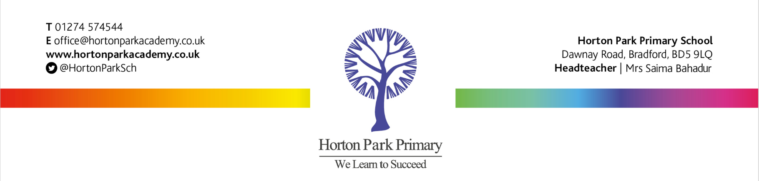

**Horton Park Primary School**

**Job Vacancy**

**Lunchtime Supervisor - Band 3, SCP 2 (actual salary £3798)**

**Part Time: 7.5 hours weekly. Term time only**

Horton Park Primary School is looking to appoint a caring and friendly Lunchtime Supervisor. You will be responsible for supervising children at lunchtime, both whilst eating and in the play area, leading play activities and ensuring the safety, well-being and good behaviour of all pupils.

Horton Park is a vibrant two-form entry primary school for children aged 4 to 11 years old with 421 pupils currently on roll. The school boasts excellent facilities and the recent addition of a Key Stage One School Led Resource Provision, which caters for the needs of children with generic complex needs.

Located in the heart of the Canterbury estate, within the culturally diverse Great Horton area. The school possesses an excellent reputation within the local and wider community. Horton Park is a school where ‘everyone learns to succeed’ and we provide our children with the cultural capital they need to be successful in our thriving community and beyond.

Exceed Academies Trust believe that successful schools develop their own identity and individuality and are best placed to meet their own community’s needs. We believe that partnership working, the sharing of good practice and being outward facing as an organisation supports our aims and leads to outstanding results.

Duties will include:   
• Supervision of pupils in the play area  
• Supervising children indoors in the event of bad weather  
• Playing games with the children  
• Reporting incidents and accidents to the appropriate members of staff  
• Supporting and implementing the school’s Behaviour Policy  
• Associated duties

You must have a good understanding of caring for children. The ability to work effectively as part of a team is essential.



Closing date for applications: Monday 16th September 2024 @ 12:00

Interview date: Friday 20th September 2024

**Prospective applicants are welcome to visit the school by prior arrangement.**

Exceed Academies Trust is committed to safeguarding and promoting the welfare of children and young people and expects all staff to share this commitment. Shortlisted candidates will be subject to related online content checks, in line with Keeping Children Safe in Education 2023. All appointments are subject to an enhanced DBS check as well as successful completion of a probationary period.

If you wish to apply for this role, please visit our school website [www.hortonparkacademy.co.uk](http://www.hortonparkacademy.co.uk) or Trust website [www.exceedacademiestrust.co.uk](http://www.exceedacademiestrust.co.uk) to download an application pack.

Completed applications should be submitted to [shazia.akhtar@hortonparkacademy.co.uk](mailto:shazia.akhtar@hortonparkacademy.co.uk).

***Please note, we do not accept CVs.***

*Exceed Academies Trust strives to be an employer of choice.  We are an inclusive and diverse multi academy trust and ultimately, our aim is to employ a workforce that reflects the communities it serves.  We are committed to achieving a balanced workforce at all levels, whilst ensuring that no individual is disadvantaged or treated less favourably.  We welcome applications from candidates of all backgrounds, faiths and ethnicities and will ensure a fair recruitment process without discrimination, in compliance with the Equality Act 2010.*