01.06.20

Dear Parents / Carers

We hope you have had a lovely half term break. Following previous communication with you regarding the wider reopening of schools, I would like to confirm that we will be opening school for the following groups of children if this has already been agreed with the school:

Key Worker / Vulnerable Families – From 1st June 2020
Reception – From 8th June 2020
Year 1 - From 15th June 2020
Year 6 – From 22nd June 2020

The school has taken reasonable and appropriate measures in line with government guidance to try and maximise the safety of the children and staff on site.

School Entry and Exit Points: There will be signs and staff to support you with this when you arrive onto the school site.
Key Worker / Vulnerable Families – Small Hall Corridor Entrance
Reception – Year 2 Classes
Year 1 – Year 3 Classes
Year 6 – Exceed side gate via top carpark

Some of the measures in place are listed below and these MUST be followed at all times:
- School will be open for identified children from 8.30 – 3pm daily (Monday to Friday)
- The breakfast club provision has been cancelled until further notice.
- You will need to remain with your child until they have been greeted by an adult.
- No items to be brought in from home; including packed lunches or snacks. A sandwich lunch will be provided by the Local Authority.
- All children to wear non uniform and these must be changed and washed regularly.
- Basil Street gate will remain closed until further notice. The main access route to be used and please follow all guidance which will be displayed.
- Children will be in small groups and will be supervised by specific adults (these adults may not be the usual class staff).
- The small groups will be known as ‘protective bubbles’. This means no other child or adult will enter this group once it has been created. For this reason if your child is absent for 2 or more days without a reasonable justification for their absence, they will not be allowed to return to school.
- Each group will have their lunch in class and will be allocated specific toilets and outdoor areas to access and maintain social distancing.
- Each group will consist of no more than 10 children. This is due to capacity space in the classroom. We will make every effort to regularly ensure areas are kept clean and that children and staff are following the school’s hygiene procedures at all times.
- Children will not have access to soft toys, soft furnishings and other smaller equipment.
- Each child will be allocated their own work space and individual resources, where possible.

Please continue to follow the government guidance if any member in your household displays any symptoms of Covid-19. If there are any further questions please do not hesitate to contact us via the school email, info@hortonparkacademy.co.uk

We will be following the guidance below in response to any suspected Covid-19 cases / symptoms.
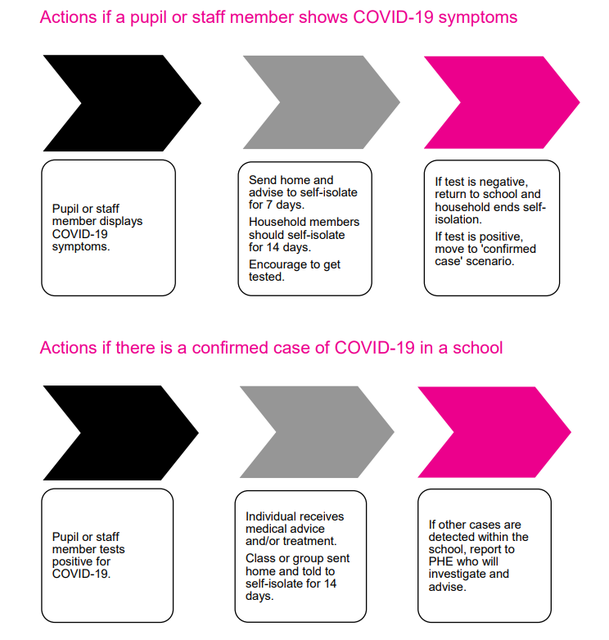

Yours Sincerely

Saima Bahadur
Head of School

